**fJournal Report 20**

**02/02/2024**

I have been looking at different anomaly aggregators and forecast models, but I haven’t been able to implement one that can predict over a long period. I spent class time researching the TFT model and seeing whether or not it was a fit for my project. Here are some of my notes:

Pros

* Effective Temporal Modeling: excels at capturing temporal dependencies
* Flexibility: handle various types of time series data, including multivariate time series with multiple input features and irregular time intervals
* Scalability: scales well to large datasets and can be efficiently trained on parallel computing architectures

Cons

* Complexity and Computational Cost
* Data requirements: requires large amount of labeled training data
* Hyperparameter tuning: TFT involves several hyperparameters that need to be carefully tuned to achieve optimal performance

These are the sources I used:

<https://towardsdatascience.com/temporal-fusion-transformer-time-series-forecasting-with-deep-learning-complete-tutorial-d32c1e51cd91>

<https://www.playtika-blog.com/playtika-ai/multi-horizon-forecasting-using-temporal-fusion-transformers-a-comprehensive-overview-part-1/>

**02/05/2024**

I spent the class time manually changing the hyperparameters of the RNN forecasting model. It seems to be performing relatively well. I noticed that higher input chunk length values make the model more sensitive to voltage fluctuations and more closely align the B field with the Set B field.

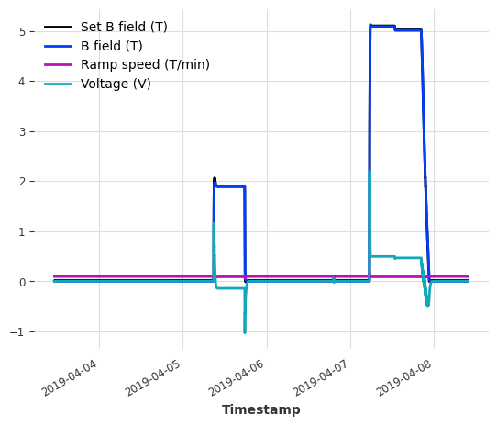

model = RNNModel(input_chunk_length=100, output_chunk_length=1, n_epochs=10)

The graph above shows the results of the model with the hyperparameters shown in the code segment. Currently, manual training takes about 5 minutes for each model. This isn’t ideal so I’m thinking about changing the number of epochs to 5. My goal is to have the same variability and noise in the Voltage variable as seen in the actual data.

**02/07/2024**

I spent the class researching the grid search method. I believe that it will be faster to implement my version of the grid search method rather than trying to figure out what each parameter within the Darts library means.

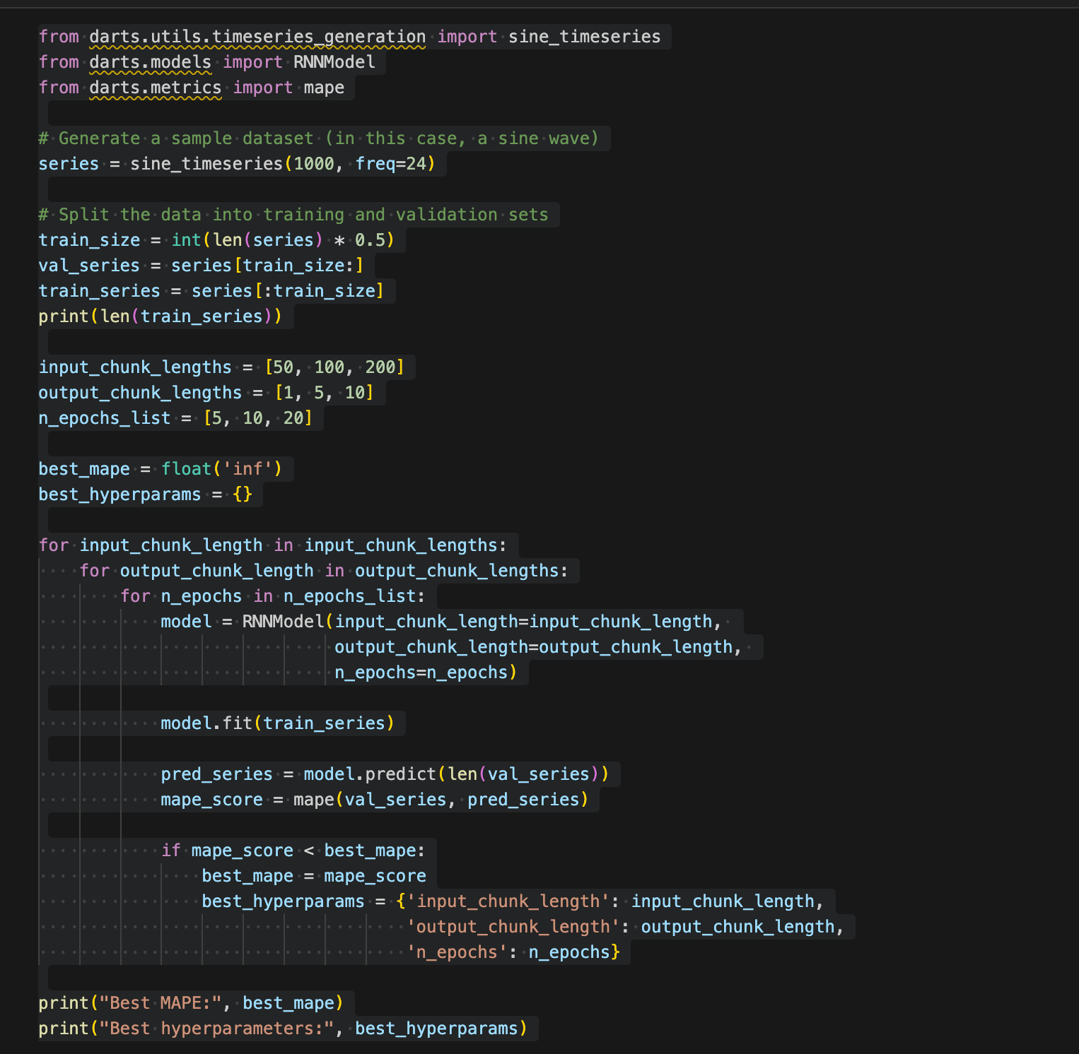

I am getting the follow error when I run this code:

ValueError: index can only be generated with exactly two of the following parameters: [`start`, `end`, `length`]. Observed parameters: ['start']. For generating an index with `end` and `length` consider setting `start` to None.

As a result, I am hoping to troubleshoot this problem and have a working implementation by the end of Friday’s class.

My research was from these two sources:  
<https://medium.com/fintechexplained/what-is-grid-search-c01fe886ef0a#:~:text=Grid%20search%20is%20a%20tuning,also%20known%20as%20an%20estimator>.

<https://www.analyticsvidhya.com/blog/2021/06/tune-hyperparameters-with-gridsearchcv/>